YouTube
Milestone: Make at least average of 100 long form videos to get 1000 subscribers
- Monetization eligibility
  - 500 Subscribers
  - 3 Public uploads in 90 days
And one of the following
  - 3000 public watch hours in last 12 months
  - 3M public shorts views in last 90 days

- Develop Interesting Video Ideas.
  - Video Ideas: - Topic (What is this Video about) + Format (How the video is presented or structured, describe the video without mentioning the topic because your topic is there to do that job)
  - Interesting Videos
    - Don’t be boring
    - Have a good timing (Editing, content)
    - Be up to date with latest trends to retain that interest factor.
    - Have a good Supply & Demand. If people want more travel vlog, give them that. If they want more cinematic videos, give them that. The Demand of one search keyword is higher, the more opportunity you have to create that type of content for more impression.
- Craft attention-grabbing Packaging.
  - Title of video should relate to your Thumbnail to grab more clicks & seize more opportunities to impress people and convert them into your loyal audience.
- Create Great content
  - Content that stimulates them enough to retain them.
  - Doesn’t have annoying friction points that cause them to leave.
  - Make them leave satisfied with their decision to watch your video.
- Be Consistent to train the algorithm
  - Be consistent about
    - How you shoot your video like from phone for vlogging, DSLR camera for photography, Go Pro for journey to make the shooting quality consistent which would bring the kind of audience you want.
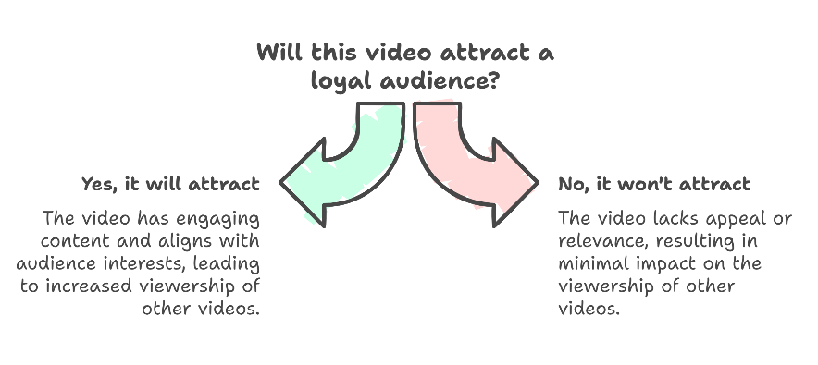
    - Golden Rule:

- Cultivate impactful X-Factors.
  - What’s your goal & what value do you want to bring to your audience. Like make dramatic videos, comedy videos or be known for most beautiful transitions which would bring excitement, humor or just the ‘Woah’ factor.
  - Be unique in your niche which your audience would appreciate about you & your channel.
  - Embrace your USP that would make you standout over others in your niche.
- Upload videos Frequently.
  - Upload as many as videos possible. One will hit more views and boost the feed of other videos.
  - Recommendations
    - Long Form Videos
      - Post 1-2 long form videos/week
      - Minimum – 1 Long form video/2 weeks
    - Shorts
      - 7 shorts/week
      - Minimum – 3 shorts/week
    - Video Formats to cover videos upload gap
      - BTS
      - Your process
      - Tutorials
      - Challenges
How to find more viral videos ideas

Instagram
- Stick to the niche
  - If its about quality cinematic videos, stick to it
  - If its about Itinerary, stick to it
  - If you want to make content related to both or more topics, stick to one core topic.
  - Pick the topic you have passion for, experience in & is fun to you to do it.
- Create a content pool
  - Create a document for your ideas about your content and post content accordingly.
  - If don’t, search your topic and see reel which have over 1M Views. Save all of them for the content pool.
- Best of 9 Strategy
  - Select 3 reels from the content pool
  - Select them on the basis of what you feel most comfortable recreating & what you’re capable of recreating in terms of location & the way it’s filmed.
  - Create & post of these formats 3 times giving you 9-reel post.
  - Check which reel performed the best in each format.
  - Compare them with each other & find out what these reels have in common like video quality, audio quality, visuals format, hook, title on the screen, caption.
  - Now use the data to create engaging reels bringing you more impressions.

Twitter
GAP Framework
Growth Content: - Any content that relates to trending topics & well-known figures in your niche or you can tie to your content.
Authority Content: - Content that help other people in your niche.
Personal Content: - Share your story, failures, struggles, transformation, opinion that other people want to come to you for. This will make you unique, relatable & emotionally connected that will bring in Loyal audience.
Make profile with these topics in mind: -
- Profile Photo: - Make unique and attractive so that it is identifiable on the feed page.
- Banner: - Match the vibe of your banner to the vibe of your account.
- Bio
  - Part 1: - What your account is about
  - Part 2: - Establishes your authority on the niche or shows your accomplishment or capability OR share where you’re documenting your journey. Blogs on a website, journey videos on YouTube etc.
- Username
- Pinned post: - Something strong like how you developed your passion for your niche (Ladakh Story), for sales purposes, your best work & how you arrived there.
Post content regularly about what you want or going to do, what you learned or anything interesting to your niche to retain you audience & grow on Twitter.
Grow – Post 1-5 post regularly
Boost – 1-3 Long post/week

